Block of the Month for June 2011

SCRAP INSANITY – BALKAN PUZZLE
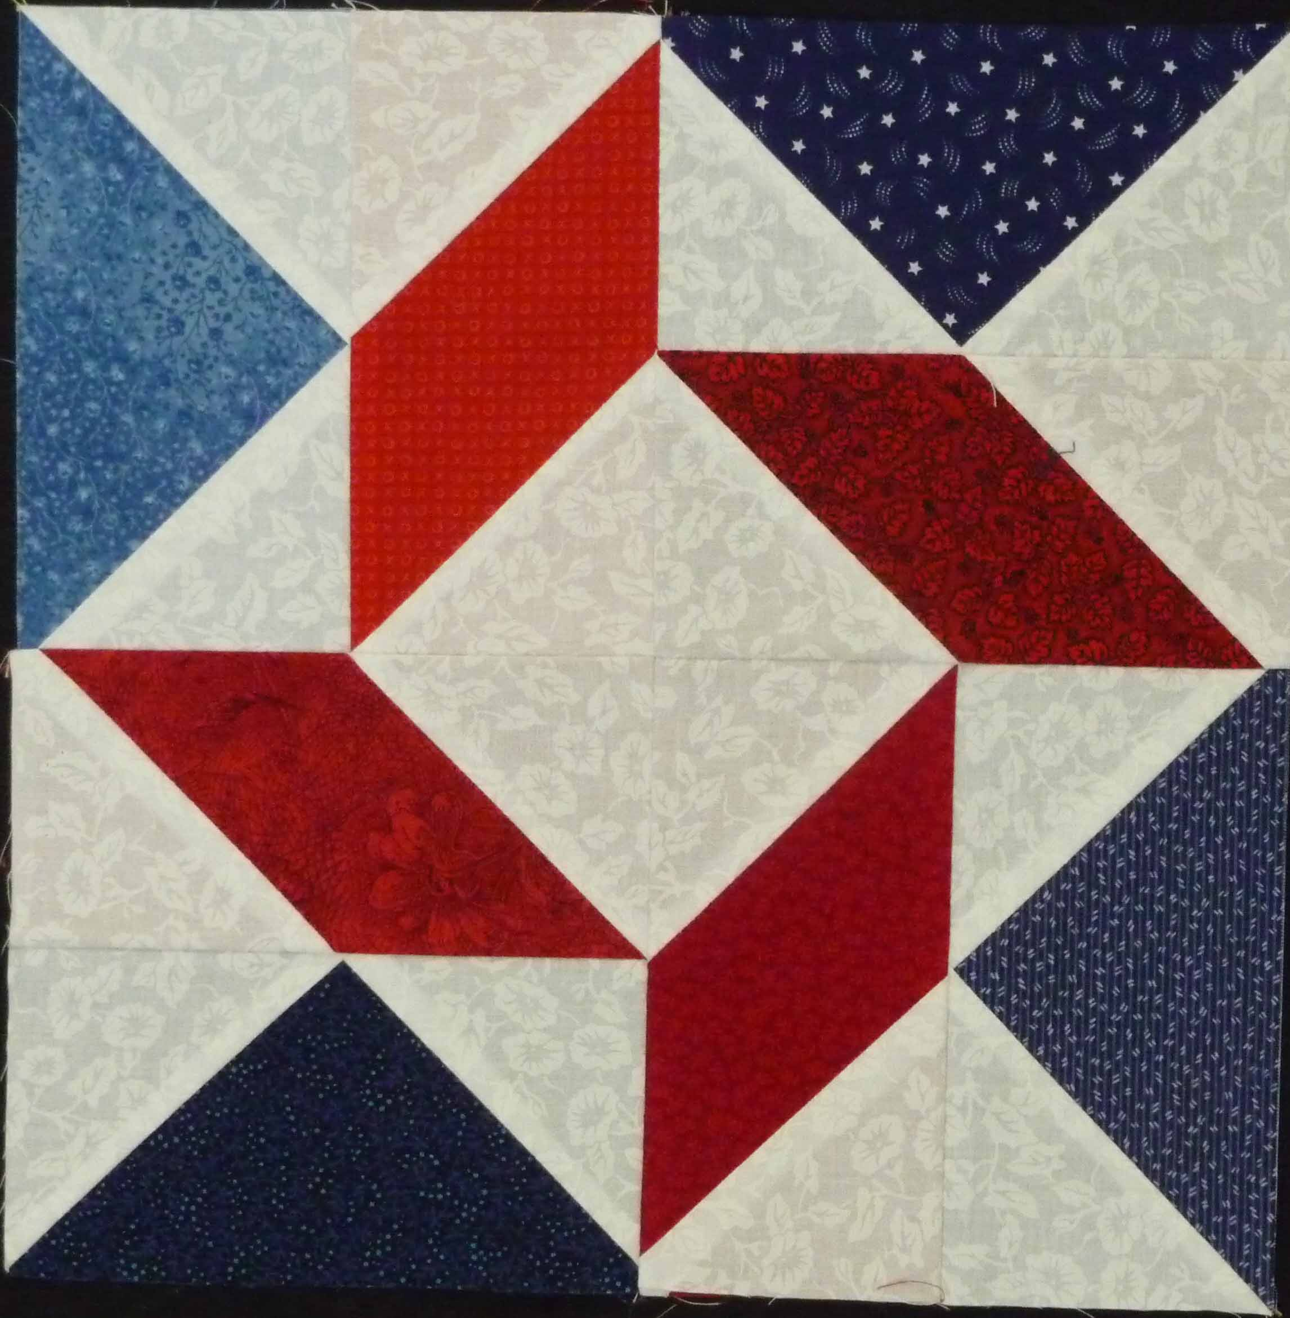
The Balkan Puzzle block is also known as ‘Windblown Square’ and ‘Zigzag Tile’. This is traditionally a three color block and we have chosen to make ours Red, White, and Blue. This block can also be made using half square triangles but we have opted for a more traditional assembly method.
There are 24 pieces to this block and it will finish to a 12 1/2” square.

FABRIC:
Background – white. Cut 16 – 3 1/2"squares.
TIP: Lightly mark a diagonal line on the wrong side of your background squares.
Red scraps. Cut 4 rectangles 3 1/2" x 6 1/2".

Blue scraps. Cut 4 rectangles 3 1/2” x 6 1/2”.

ASSEMBLY:
Make 4 Flying Geese.
Using your blue scraps, place a background square on top of a rectangle with right sides together. Sew on the diagonal line.
Trim seam to 1/4" and press toward the background fabric.
Place another background square on the opposite side of the rectangle with right sides together. Sew on the diagonal line.
Trim seam to 1/4" and press toward the background fabric. Flying Geese should measure 3 1/2" x 6 1/2".
Make 4 Parallelograms.
Using your red scraps, place a background square on top of a rectangle with right sides together. Sew on the diagonal line.
Trim seam to 1/4" and press toward the background fabric.
Place another background square on the opposite side of the rectangle with right sides together. Sew on the diagonal line.
Trim seam to 1/4" and press toward the background fabric. Parallelogram should measure 3 1/2" x 6 1/2".
Final Assembly:
Sew a Flying Geese unit and a Parallelogram unit together to form one quarter of the block. Repeat 4 times. Press the seam toward the parallelogram.
Assemble the quarter blocks as shown in the photo above.
Having problems with the block? We are here to help.
Cathe, Darilyn, & Kathy

